**Connecting NodeMcu to the Wifi NetWork:**

1st we do some code to connect NodeMcu to Wifi network,

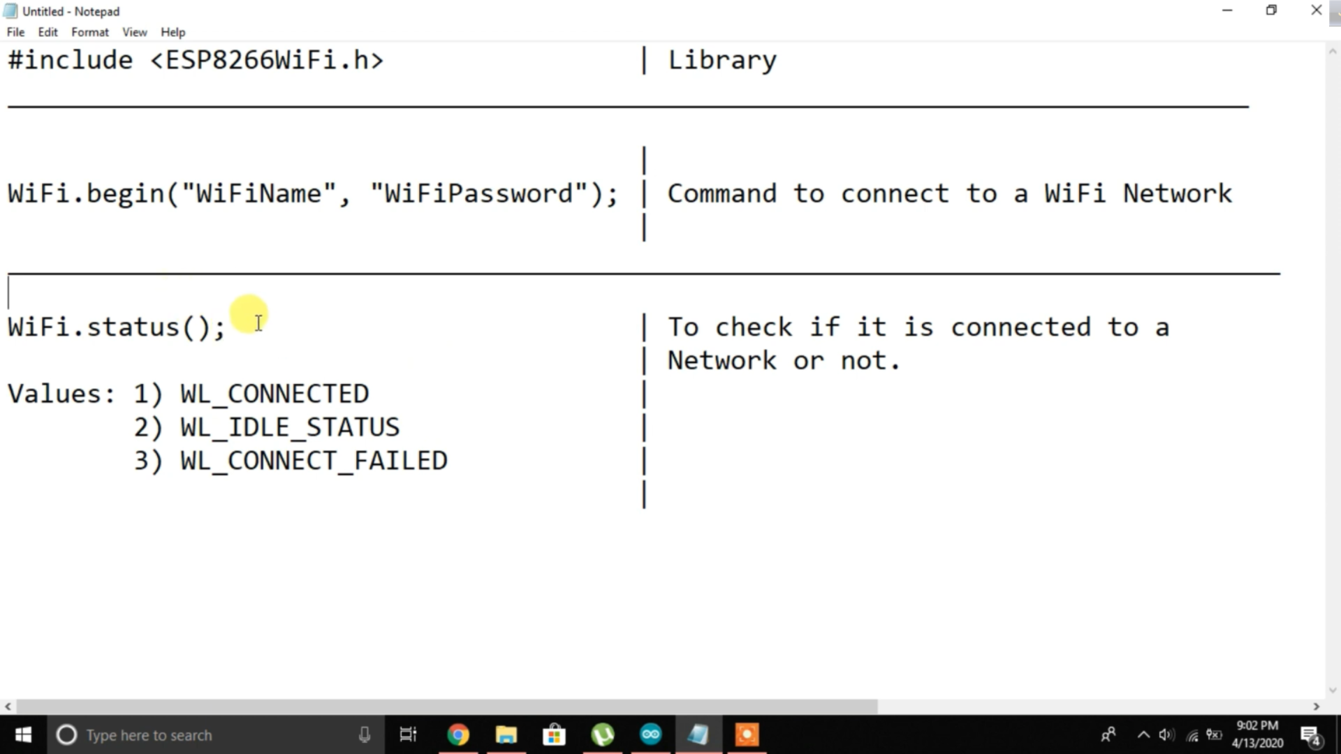

**Code:**

|  |
| --- |
| #include<ESP8266WiFi.h>  void setup()  {  Serial.begin(9600);  WiFi.begin("Redmi note", "123456789");    //WiFi.begin(“WiFi name”, “password”);  while(WiFi.status()!= WL_CONNECTED)  {  Serial.print("..");  delay(200);  }  Serial.println();  Serial.println("WiFi is connected");  Serial.println(WiFi.localIP());  }  void loop()  {    } |

After uploading this code we will get,

